Uber Take Home Evaluation
Jeffrey Uslan

Part 1 - SQL

1. Between Oct 1, 2013 at 10am PDT and Oct 22, 2013 at 5pm PDT, what percentage of requests made by unbanned clients each day were canceled in each city?

SELECT COUNT(CASE WHEN status IN ('cancelled_by_driver','cancelled_by_client') THEN 1 END)/COUNT(*) AS daily_city_completion_percent, date, city_id
FROM (
SELECT status, DATE(request_at) AS date, city_id
FROM trips
WHERE request_at BETWEEN ('2013/10/01 03:00:00','2013/10/22 10:00:00')
AND client_id IN (
SELECT userid
FROM users
WHERE role == 'client' AND banned == 0
)
)
GROUP BY date, city_id
;

2. For city_ids 1, 6, and 12, list the top three drivers by number of completed trips for each week between June 3, 2013 and June 24, 2013.
SELECT completed_trips, driver_id, week
FROM (
SELECT COUNT(*) AS completed_trips, driver_id, week, row_number() OVER (PARTITION BY driver_id, week) AS rownum
FROM (
SELECT WEEK(request_at) AS week, driver_id
FROM trips
WHERE request_at BETWEEN ('2013/06/03 00:00:00','2013/06/25 00:00:00')
AND driver_id IN (
SELECT userid
FROM users
WHERE role == 'driver'
)
AND city_id IN ('1','6','12')
AND status IN ('completed')
)
GROUP BY driver_id, week
ORDER BY completed_trips DESC
)
WHERE rownum <4
;

Part 2 – Experiment and Metrics Design

A product manager on the Growth Team has proposed a new feature. Instead of getting a
free ride for every successful invite, users will get 1 Surge Protector, which exempts them
from Surge pricing on their next surged trip.
1 . What would you choose as the key measure of the success of the feature?

As the impetus of this proposed new feature was gaining more customers via successful invites I would use successful invites as the key measure of success.

2. What other metrics would be worth watching in addition to the key indicator?

Other metrics to be concerned about upon adding this new feature would be change in invitations sent/posted, change in percent of successful invites, lifetime value of gained customers, and projected lost revenue from Surge Protectors.

3. Describe an experiment design that you could use to confirm the hypothesis that your
chosen key measure is different in the treated group.

I would propose that a stratified selection among key demographics of approximately 1% of each population be selected to participate in the new feature. I would allow the experiment to run for a period of at least 3 months. After such a time I would collect summary statistics on the key measures discussed above and test for statistical significance between the populations.

Part 3 – Data Analysis

1. Exploration and Visualization

The data provided shows that customers are retained 69.2% percent of the time- according to this sample.

The table below shows the mean values of important numerical variable across their corresponding retained status.

Retained | Distance | Weekday | Passenger Rating | Driver  Rating
0 | 6.01 | 61.72 | 4.79 | 4.634
1 | 5.25 | 61.08 | 4.77 | 4.589

The figure below shows histogram of the distances of drives faceted by customer retention.

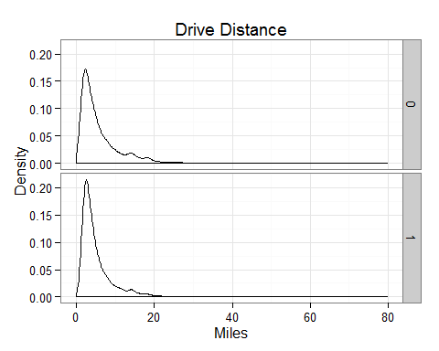

The figure below shows histogram of the weekday drive preference of drives faceted by customer retention.

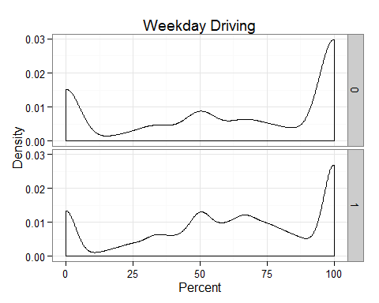

2. Predictive Model

I built a random forest model on customer retention using average distance, weekday percent, driver rating, passenger rating, surge percent, average surge, city, uber black user, and phone as co-variates. The model was built on 60% of the original non-missing data. The random forest was 82% accurate on the training data and 72% accurate on the remaining 40% testing data. The figure below shows the descending importance of each predictor according to the Gini information index.

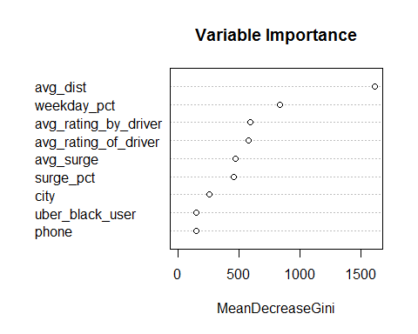

3. Recommendations based on findings
According to the model and tabulation the average drive distance and weekday ride preference are the most informative variables. Uber is more likely to retain customer who take short rides and customers to request rides on weekends, though the latter is a very small difference. Based on these findings I would suggest Uber target customer based on their potential ride distances and weekend use proclivity.

